**VECTR v4.4.1 Feature Breakdown**

Table of Contents

Tagging System 2

Assessment Group Templates 4

Running SSL in Docker 6

# Tagging System

What is it?

VECTR can now tag Test Cases for easy access and organization.

How does it work?

There is now a “tags” section in the Test Case popup:

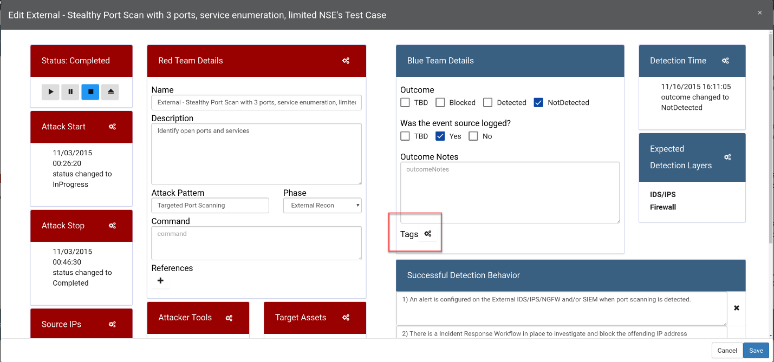

Clicking this will bring you to a selection screen with all your tags. If there are no tags created, you can create one by clicking Add/Edit Labels:

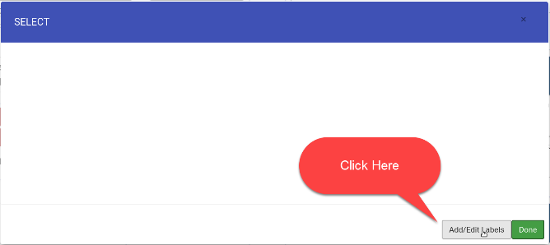

Now you can select a color at the bottom, then give your label custom text: 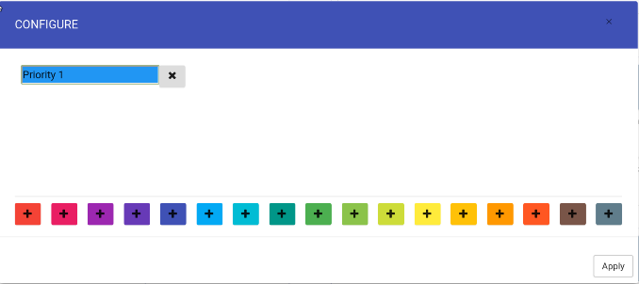

Now that a new label is created, select it to apply to this Test Case, and click Done:

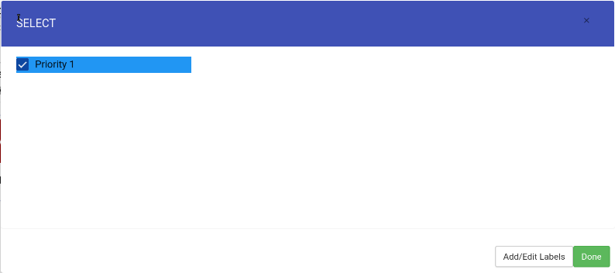

You should now see the label in the Test Case:

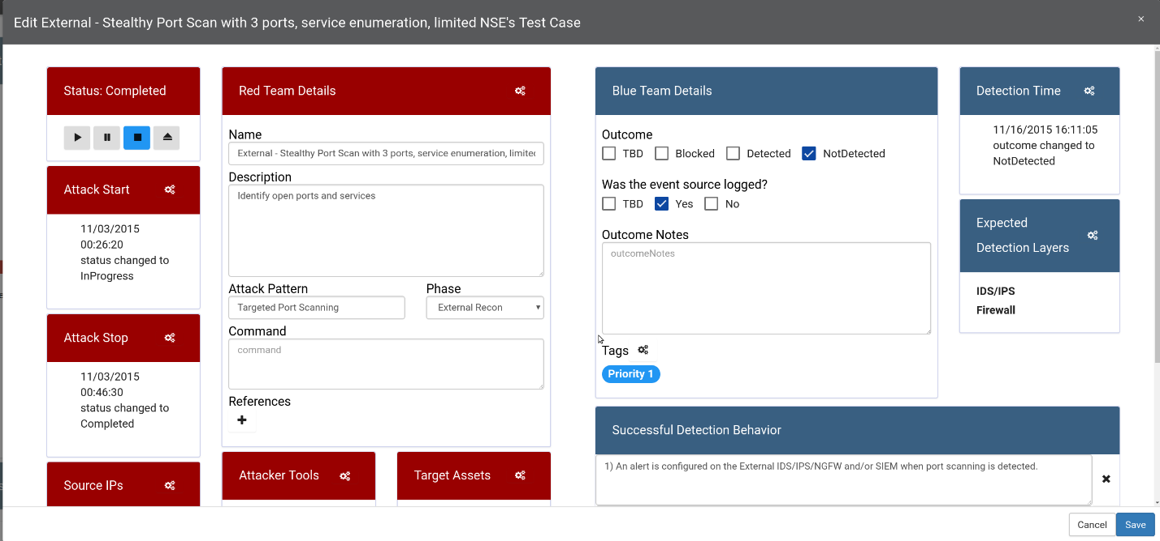

How can this feature help me?

Tagging Test Cases allow you to see important information in the scorecard:

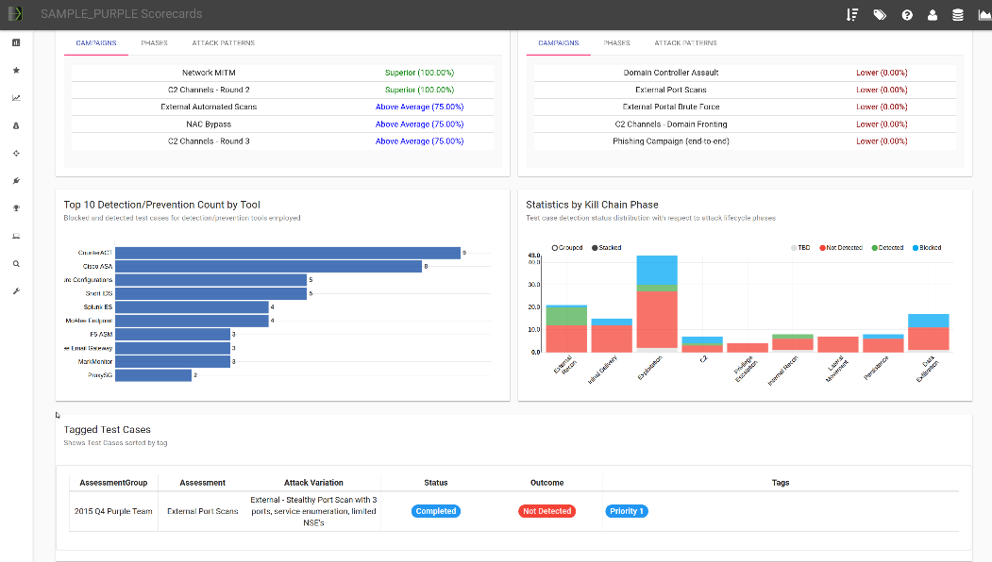

You can also access a view dedicated to tags:

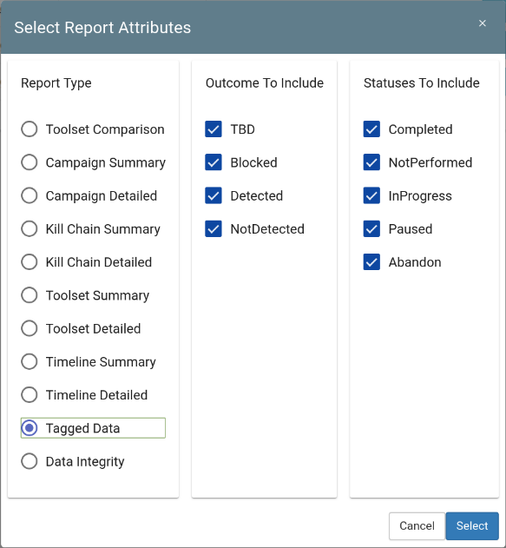

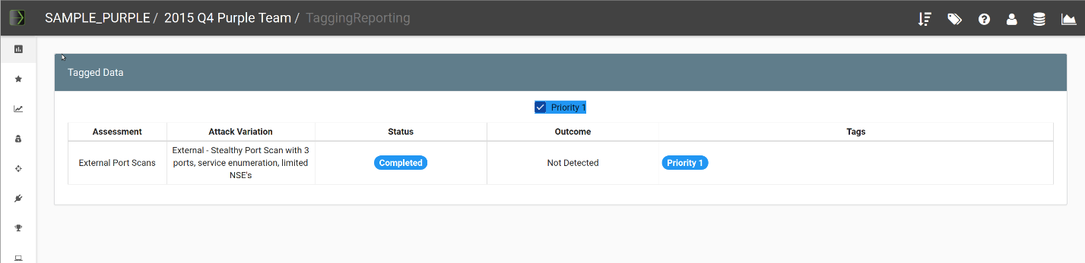

You can quickly navigate to your tagged data by accessing the quick launch in the top right of the display:



# Assessment Group Templates

What is it?

Assessment Group Templates allow you to logically group campaigns together into reusable templates.

How does it work?

In your Administration, click on Group Templates

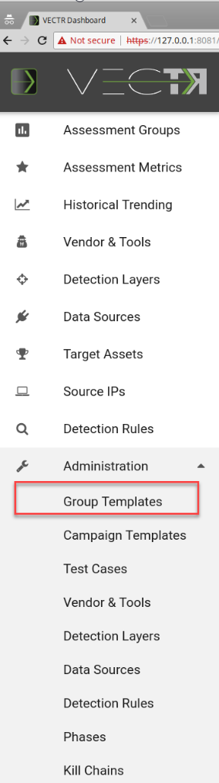

Click New, then fill out your template with the desired campaigns:

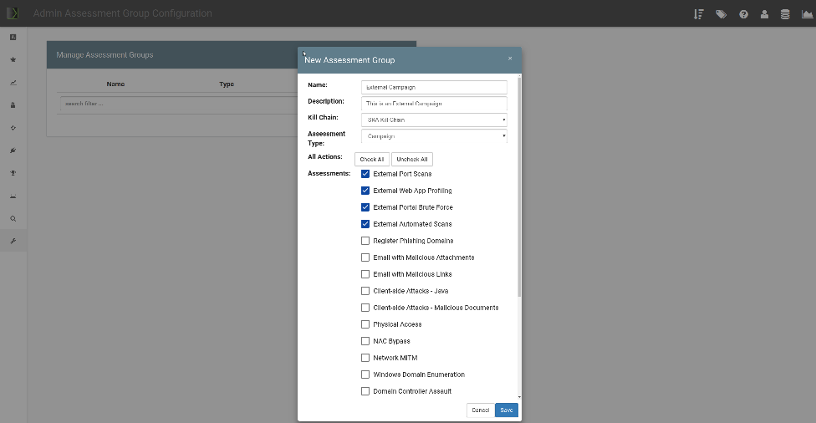

Back in the Assessment Group screen, when you click “New”, you’ll be able to select from your Template:

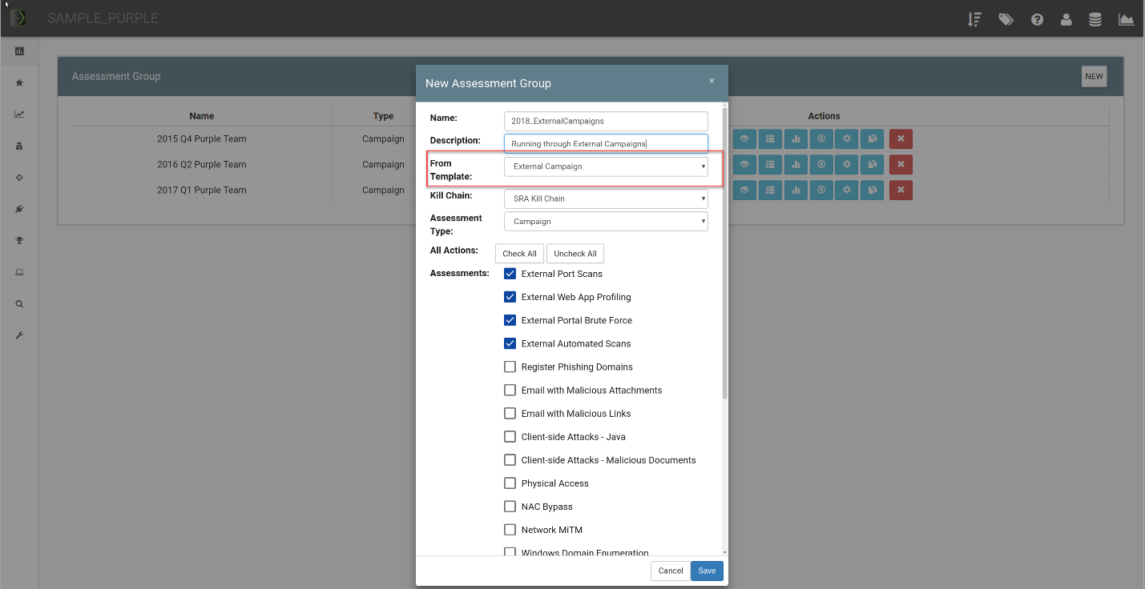

# Running SSL in Docker

What is it?

Allows you to run HTTPS from your docker container.

How does it work?

See <https://github.com/SecurityRiskAdvisors/VECTR>, section #4.

How can this feature help me?

This feature allows you to communicate to the Tomcat server on the docker container via https using a certificate of your choice.